# Cryptography Homework 4--KEY

# Turn in

This data is the same for all three attempts:

p = 131

q = 157

n = 20567________________________ p*q

### Attempt 1, using Λ(n)

Λ(n) = 780_________________________ lcm(p-1, q-1)

e = 17__________________________(I chose 17, student choices will be different.)

gcd(e, Λ(n)) = _______________________ must equal 1. If not, pick a new e

d = 413_________________________ findModInverse(e, Λ(n))

public key [n, e] [20567, 17]______

private key [d, e] [20567, 413]_____

plaintext integer 12345_________

ciphertext 7315__________ pow(plaintext, e, n)

decrypted text 12345_________ pow(ciphertext, d, n)

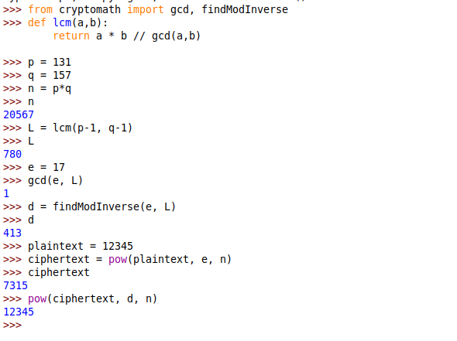

### Attempt 2, using Φ(n)

Φ(n) = 20280_____________________ (p-1)*(q-1)

e = 17________________________ Use the same e that you used in Attempt 1

d = 1193______________________ findModInverse(e, Φ(n))

public key [n, e] [20567, 17]____

private key [d, e] [20567, 1193]__

plaintext integer 12345_________ Use the same plaintext that you used in Attempt 1

ciphertext 7315__________ pow(plaintext, e, n)

decrypted text 12345_________ pow(ciphertext, d, n)

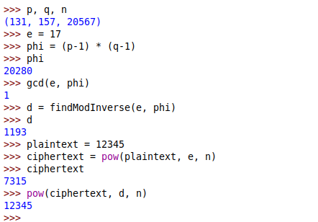

### Attempt 3, using n (should fail)

n = 20567_____________________ n, same as above

e = 17________________________ Use the same e that you did in Attempt 1

d = 7259______________________ findModInverse(e, n)

public key [n, e] [20567, 17]____

private key [d, e] [20567, 7259]__

plaintext integer 12345_________ Use the same plaintext that you used in Attempt 1

ciphertext 7315__________ pow(plaintext, e, n)

decrypted text 4726__________ pow(ciphertext, d, n)  
**Wrong!! You can compute d using either Λ(n) or Φ(n), but not using n !!!!!**

